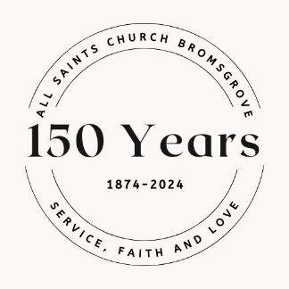
All Saints Church, Bromsgrove
1874-2024 Anniversary Celebrations
Serving our Community in Faith and Love

May Saturday 18th Books Galore! 10.30-12noon Book stall, morning papers, storytelling, refreshments
June Saturday 29th Organ Recital by Olliver Neale 1pm
Free entrance, donation invited
July Friday 5th Anniversary Quiz & Beetle Drive 7pm
£10 ticket per person including quiche and chip supper (teams of 4)
Saturday 6th Organ Recital by Ashley Wagner 1pm
Free entrance, donation invited

Festival Week
July Saturday 6th Festival Exhibition opens 2.30pm
Exhibition open Monday-Friday of Festival Week 2.30pm-5pm
Sunday 7th Festival Evensong 6pm
Saturday 13th Gala Organ Concert: Charle Francis 7pm
£10 tickets on the door (includes refreshments)
Sunday 14th Team Festival Eucharist 10.30am
With +Martin, Bishop of Dudley

Saturday 20th Summer Fair 1pm-4pm
Flute Recital in church at 1pm with Elizabeth Haining and Oliver Neale
Saturday 27th Come and Sing
Join the instant choir to sing Faure’s Requiem in a day!
https://www.eventbrite.com/e/come-and-sing-vivaldi-gloria-and-faure-requiem-registration-812452937607?aff=oddtdtcreator&keep_tld=1

