Tuesday 5th January 2021

Dear Friends

I am sure you will have all watched or listened to Boris Johnson last evening, explaining in broad terms the new restrictions we now face due to the rapid growth in COVID-19.

Although public worship in church is still permitted, we have taken the decision to close our churches completely until February half-term when the situation will be reviewed. We must do all we can to protect ourselves, one another and our community. Sadly, this means that all our hall activities must cease again too.

Until further notice, Sunday worship will only be available online or by telephone using the details published in the newsletter.

It is hugely disappointing to write this, even though one can hardly be surprised by last evening’s news. The vaccines are coming though, which is fantastic and we thank God for the phenomenal work involved in their design and creation. All will be well – eventually.

For now, we have a duty of care for one another, our friends and families. On your behalf, sincere thanks to all involved in the production and distribution of our newsletters which I know are valued so much.

At the moment I’m reading Corduroy by Adrian Bell, the father of Martin Bell, the journalist. It’s not a study in textiles (though I’m sure that would be interesting!) but a wonderful memoir from 1920 when Adrian Bell moved from London to a Suffolk village to learn farming. It is full of beautiful descriptions of a pre-mechanised farming life, relationships, traditions… I mention it because, of course, it was written in the shadow of one world war and before the prospect of another became a reality. Caught between two major world events, Adrian’s memories remind us that whilst we cannot escape very real difficulty or even tragedy in our lives, we can find peace and serenity in the creation that surrounds us and amongst friends and colleagues whose outlooks we share. It also reminds us, that although tragedy destroys much, it can never destroy the essentials of life – love and hope.

The virus is this generation’s terrible world event. But despite it we can find peace, love and even joy and hope. If you are able to leave home for a daily walk, take time to cherish the world we inhabit. May we all continue to cherish our family and our friends too, and may we all draw even more strongly upon our faith.

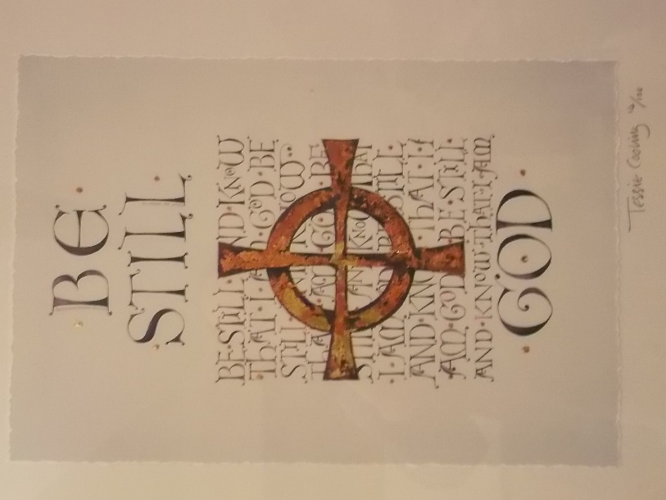
One of my favourite prints that hangs in my study is this one by Tess Cooling that draws on Psalm 46.10: Be still and know that I am God. From the beginning of the psalm…

God is our refuge and strength,
an ever-present help in trouble.

…to its end…

The Lord Almighty is with us;
the God of Jacob is our fortress.

…we are reminded of God’s presence and strength.
The Psalm includes those wonderful words quoted on another occasion by Philip to the cynical Nathanial – come and see what the Lord has done. Even if your world view for the next seven weeks is limited to the view from your window, it is still possible to glimpse the wonder and majesty of God.

Stillness is not the same as silence. Stillness is a quality of being that comes from deep within whereas silence is simply the absence of external noise.

Over these next seven weeks I am going to make a deliberate effort to find more stillness within myself. If I can slow down my thoughts, breathe more deeply, turn away from constant distractions, perhaps I can learn from the Psalmist and find more easily the stillness through which God’s voice can be heard.

Please keep in contact with one another as much as possible. If you haven’t heard from someone for a while, give them a call. If there is someone who might find a call from me helpful, please let me know.

May the peace of God fill your heart and still your mind these difficult weeks.

Assuring you of my love and prayers

David Ford, Rector
01527 873831 revdavidford@googlemail.com

